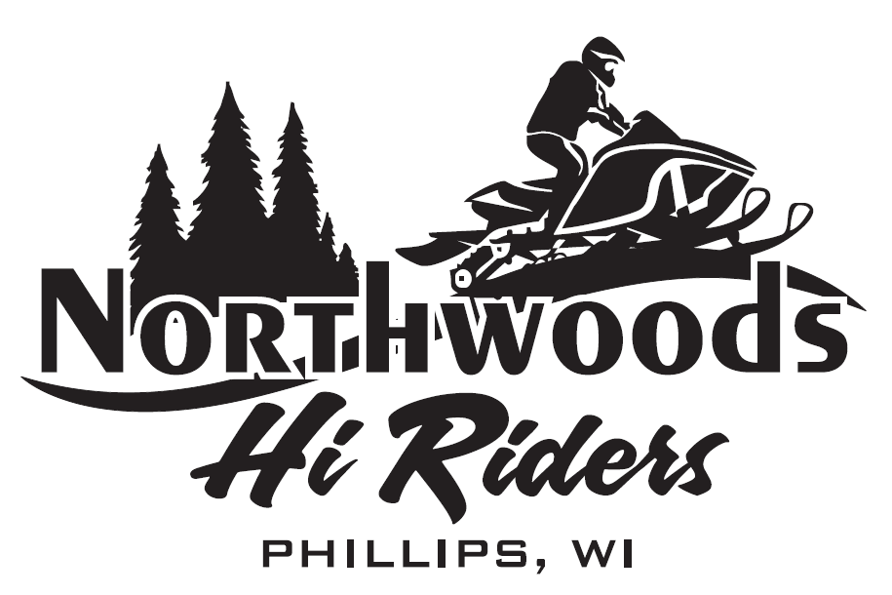
1st Annual Northwoods HI-Riders Fall Classic
4 Man 9 Hole Scramble Fundraiser
Westwood Golf Course
Phillips, WI
SATURDAY SEPTEMBER 18th, 2021
REGISTRATION @ 12:00 P.M.
SHOTGUN START @ 12:30 P.M.
$ 50.00 / Per Person Entry Fee Includes a meal
2021 Polaris 600 Hole in One prize
50/50 Raffle/ Basket Raffles/ Proxies
Contact Andrea @ Westwood to sign up

